Project Plan - Non-Invasive Face Mask Mar 27, 2020
Team Members
GDLSC
- Wes Rhiger – Leadership & Project Mgmt
- Joe Nugent – Innovation Area Manager
- Bethany Brasser – Innovation Lead, Project Mgmt
- Derek Wilson – Innovation mindset, hands-on innovation
- Kipp Eaton – Innovation mindset, hands-on innovation, scuba knowledge
- Ray Szeto – Research analyst, 3DP knowledge
- Tyler Finlayson – Innovation mindset
- James Fernandez – Innovation mindset
- Darren Ballantyne – CAD Lead
- Mike Pette – Manufacturing Lead
- TBD – SCM Lead
External
- Tarek Loubani – Lead of Emergency Medical Equipment group – London Health Sciences Center
- Azad Mashari – Anesthesia expertise, access to top clinical and research ventilation experts – University of Toronto
- TBD medical and regulatory SME’s
Objective
To design, prototype, validate, and produce a non-invasive ventilation mask to be used in a hospital environment for emergency pre-treatment of COVID-19 patients.
Schedule
- Project kickoff – Mar 30th
- 2 prototypes within 7 days of project kickoff
- Enough masks to cover London hospital needs within 3 weeks (TBC) of project kickoff
- Enough masks to cover Ontario hospital needs within 2 months (TBC) of project kickoff
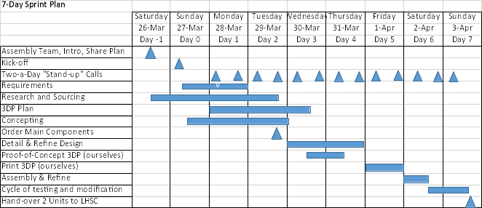
Roles and Responsibilities
GDLSC Responsibilities
- Project Management, Design, Manufacture, Supply Chain, Requirements Compliance
External Medical Partners
- Requirements definition, Regulatory Approvals, Medical Ventilation Expertise, Filtration expertise, Validation, Application Feedback
References
https://www.3mscott.com/products/av-3000-with-sureseal-facepiece/#overview
https://www.youtube.com/watch?v=Gkq5fLQiMcU
https://www.youtube.com/watch?v=Gkq5fLQiMcU
http://procrastineering.blogspot.com/2020/03/low-cost-open-source-ventilator-ish.html
https://www.isinnova.it/easy-covid19-eng/
https://www.medline.com/product/HEPA-Filters-by-Tri-Anim-Health/HMEs-and-Filters/Z05-PF40513
https://www.3m.com/3M/en_US/worker-health-safety-us/all-stories/full-story-detail/?storyid=8855304f-01cb-4af2-8937-83096cdb4113

Ground Rules and Assumptions
- This design will be open source and made freely available, world-wide.
- GDLS will pay for their own labour contributions and material prototyping for this initiative.
- LHSC will provide to GDLSC, representative non-invasive ventilator and associated hoses/adapters for interface and testing purposes
- LHSC will provide performance and interface requirements
- Funding for low-rate and full production is TBD.

Questions and Research/Information Required
- What features and benefits of a CPAP machine can we leverage?
- Are we looking to procure and existing face mask and then modify it for our purposes? If so, we need to locate best options with available supply.
- Are we trying to meet a target cost/budget per mask?
- Need to make a determination quickly on whether using a CO2 scrubbing (i.e. rebreather) truly closed-loop design, or more of a filter N95 venting based design
- Is there an existing source of N95, or equivalent, family of filter cartridges that is certified for this sort of application?
- Do we have to meet any specific safety/cleanliness requirements for assembly/manufacture of these masks?
- We will need some form of requirements from medical team.
- A basic diagram of all key components and their interfaces would be useful to ensure common understanding and to help breakdown the problem - Ventilator, hose, one-way valve in, mask, person, one way value out, filter/scrubber, loopback if required).

